Project brief description

# About

An app in order to manage stock item in a ‘technology’ shop

# Features

Listing products in order, by category and provider. A detail of a product will be shown when user tap on product’s name in the list

Also user can manage the list of category and provider, also an item

# Layout

The figure below is layout view of our project’s storyboard

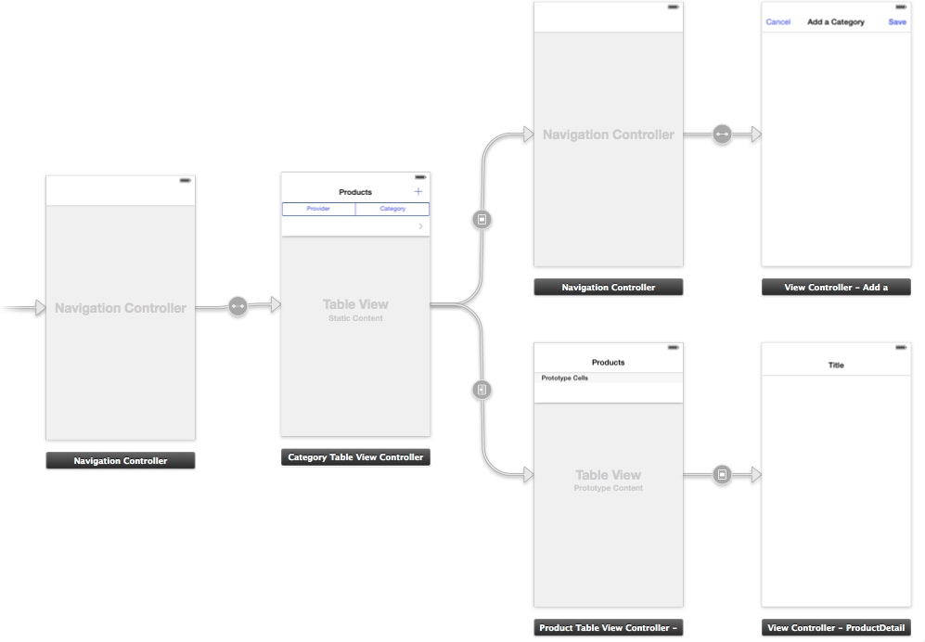

# Database and relationship

We design the database model and relationship between them as the below figure

